Task 2.1:

Part 1:
- Webhooks are automatic event driven mechanisms. This means that when a sensor reading is taken the ESP32 triggers a HTTP POST/Get request to ThingSpeak API, passing data to as URL parameters. This makes them more efficient for real time event triggered Applications. Some examples a webhooks are things like ecommerce payments like PayPal to confirm that payment has been successful or GitHub triggering an automatic build pipeline when code is pushed.

- In this projects mechanism uses an esp32 microcontroller to connect the sensor to ThingSpeak over wifi. This is code to export data to ThingSpeak when an IoT device is connected to a Wi-Fi connection. It works by connecting to the internet and using an API key to access the end point API via a webhook HTTP request and gain permission to write to it.
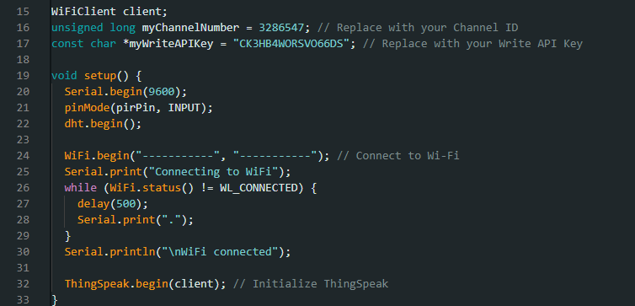

- The ThingSpeak.writefields() acts a webhook trigger by constructing a HTTP GET request to api.thingspeak.com/update, appending the API key and sensor value as parameters. This causes the device to push data without any request from the server’s side.
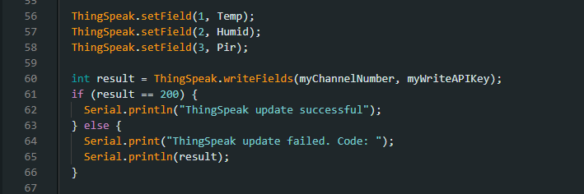

Part 2:
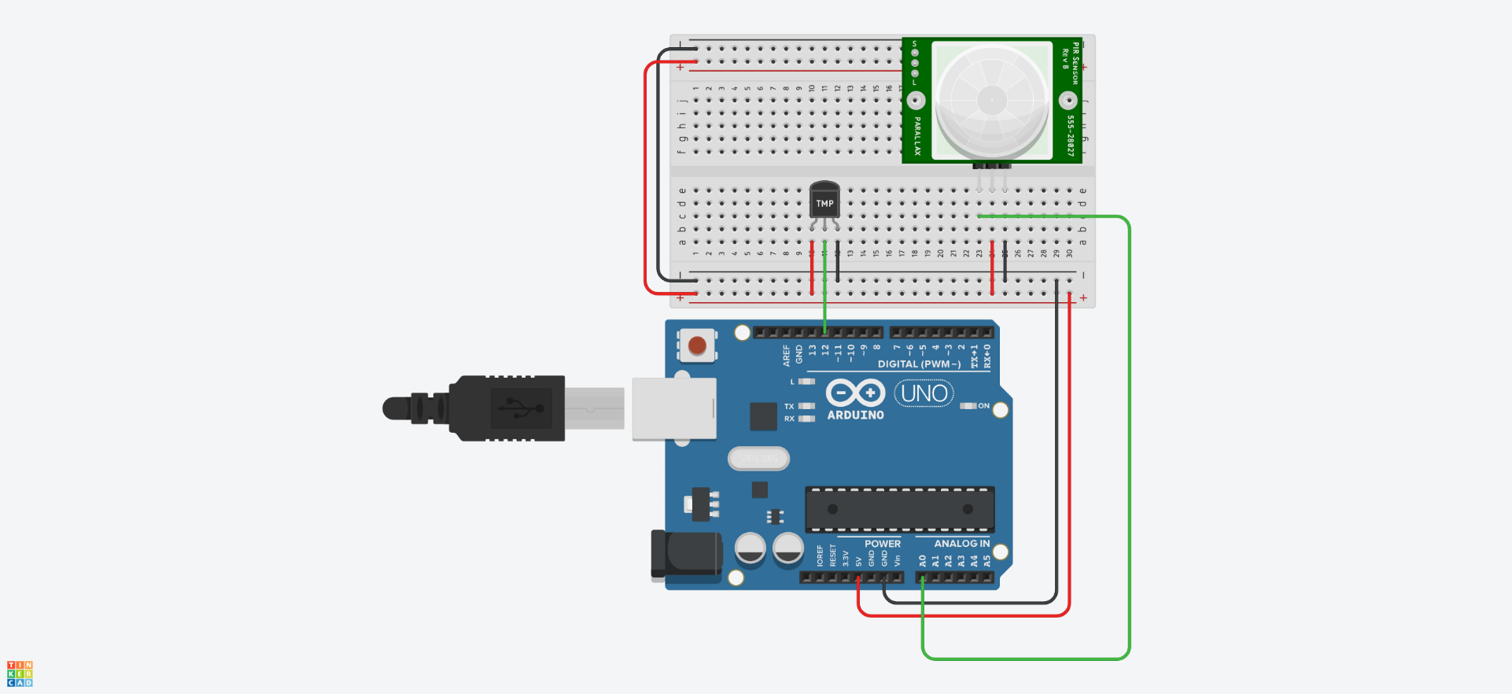

Part 3: 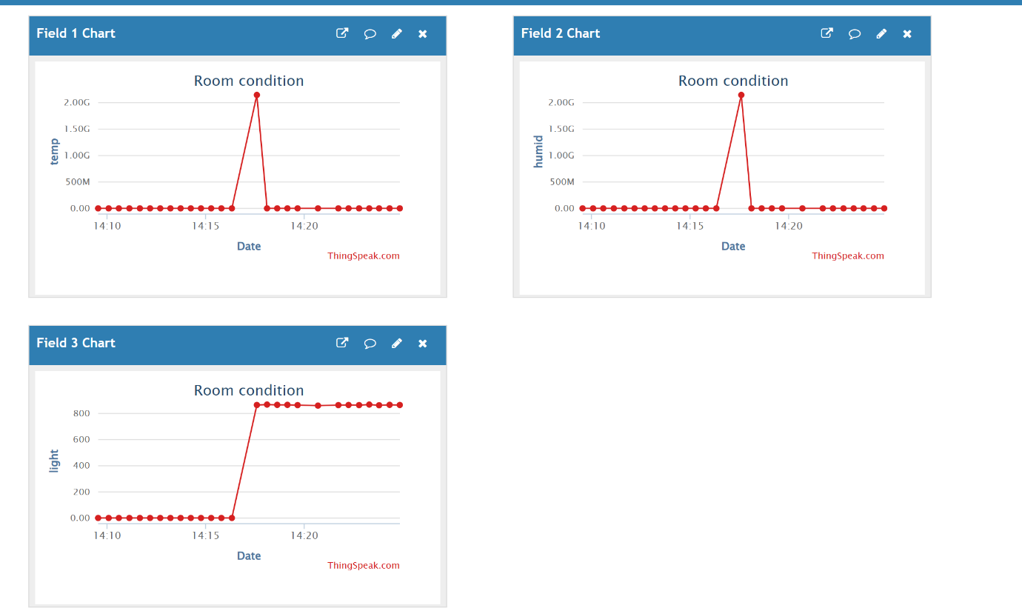
The graphs a displaying erroneous reading in places likely due to sensor instability during use. In production systems these reading would be filtered using threshold checks or moving average before uploading.
GitHub: https://github.com/charlieM044/SIT210

